Rutgers University Busch Campus

Parking Available for Attendees/Vendors in Lots 51, 67, and 67B
Parking Available for Members in Lot 59
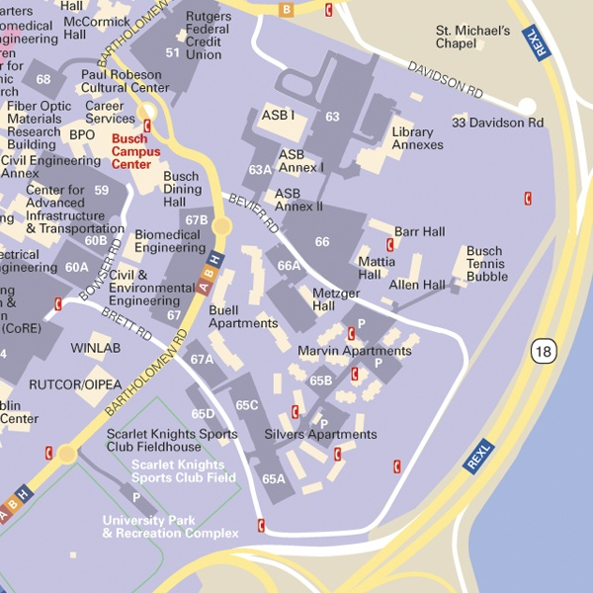

For additional information, please contact Sherry Zubris at 732-932-4375 x 2318 or zubris@rci.rutgers.edu.
© 2005 Rutgers, The State University of New Jersey. All rights reserved.

