Rutgers University Busch Campus

Parking Available for Attendees/Vendors in Lots 51, 67, and 67B
Parking Available for Members in Lot 59
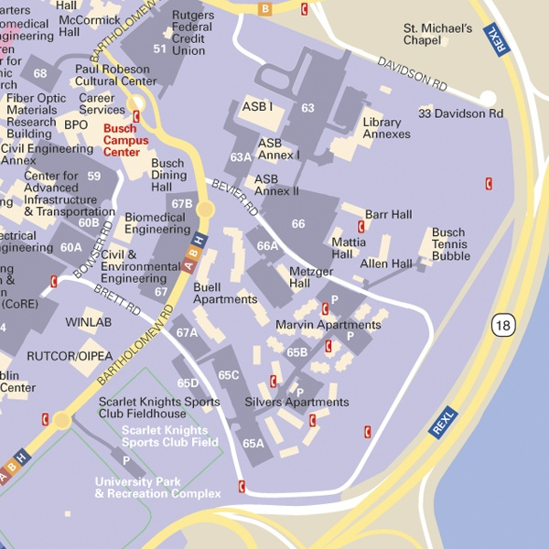

For additional information, please contact Pamela Y. McMellon-Wells at 856-225-6140 or pmcwells@camden.rutgers.edu.
© 2005 Rutgers, The State University of New Jersey. All rights reserved.

